**The Investigation of beam splitter for FIReTIP**

2/12/2016

1. **Motivation:**

The original beam splitter used to combine the vertically polarized beam and the horizontally polarized beam causes significant energy loss, as shown in Fig. 1. The original mesh grid structure of the beam splitter has 70% transmission and 30% reflection at a wavelength of 119 μm and an incidence angle of 45° with a 500 lpi mesh, as shown in Fig. 2. As a result, 70% of the power from f₁ and 30% of the power from f₂ are lost in this setup.

A wire grid polarizer can achieve high reflection for polarization parallel to the wires (E ∥ wires) and high transmission for polarization perpendicular to the wires (E ⊥ wires), making it an ideal methods for combining two lasers with orthogonal polarizations.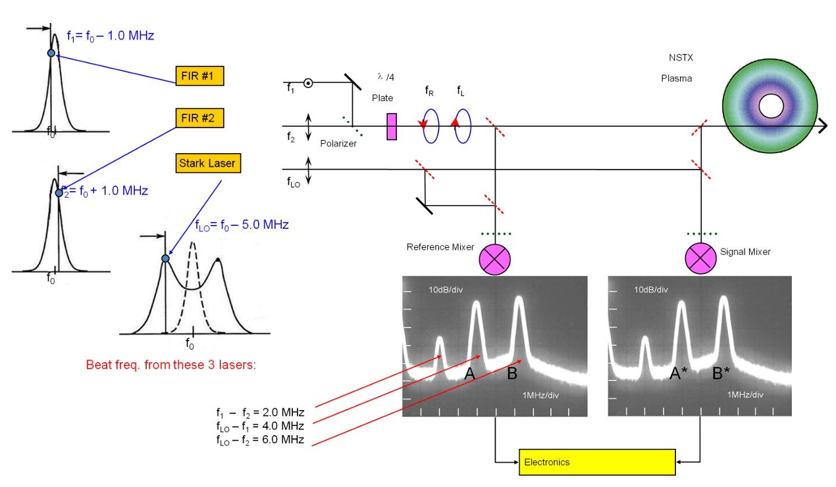

Figure . Schematic of the FIReTIP laser arrangement, laser tuning parameters, and mixer output. (Page 45, Robert’s thesis1)

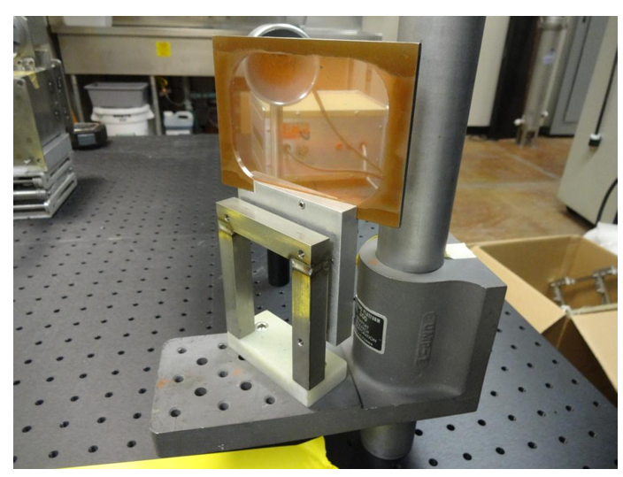

Figure .Metallic mesh beam splitter. FIReTIP has two-line densities to choose from, 500 and 400 lpi. (Page 103, Robert’s thesis1)

1. **Grid structure requirement**

To avoid high order diffraction, the grid period should be less than the wavelength, which means $Λ≪λ$. For 500 lpi, the grid period $Λ≈50.8 μm$ and $λ=119 μm$, maybe good for beam splitter, but it would be better if the structure has $Λ<50 μm$.

1. **Business Investigation**

Two company sale the Wire grid Polarizer

3.1 [Microteach](https://mtinstruments.com/index.php?main_page=index&cPath=5&disp_order=8)

**G40-S, Unit price: $1500**

**Wire diameter / Wire spacing ($μm$): 10 / 40**

**Clear aperture / External diameter (mm): 40 / 50**

The transmissions with different polarization are given in Fig.3 and Fig.4.

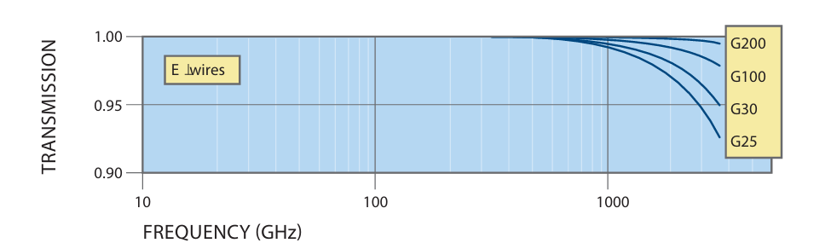

Figure . Transmission with E vertical to wire direction, from [datasheet online](https://mtinstruments.com/MicroTech_Resources/Polarizer-Datasheet.pdf)

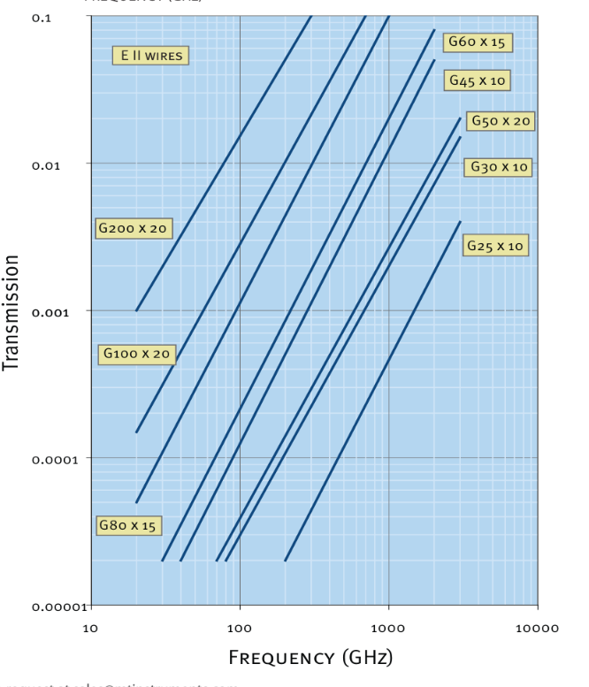

Figure . Transmission with E parallel to wire direction

3.2 [REFLEX Analytical Corporation](https://www.reflexusa.com/wigrpo.html)

**Tungsten 10µm Diameter ,25µm Spacing, unit price $1015**.(<https://www.reflexusa.com/wigrpo.html>)

**Outside Diameter/Clear Aperture/Part Number: 50mm/25mm/57201**

From Fig.5, the curvature A measured at 45o shows that when E­ is parallel to the wire direction, the reflection at 119 um is about 95%. When E is vertical to the wire direction, nearly 100% transmission is measured as shown in Fig.4. G25 refers to 25 um spacing.

I prefer buying from this company because it offers a lower price.

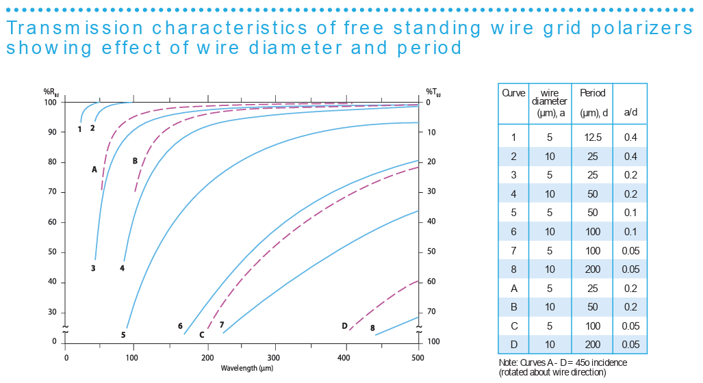

Figure . data from [online](https://sep.turbifycdn.com/ty/cdn/eeffppkk/Free-Standing-Wire-Grid-Polarizers.pdf?t=1764713719&)

1. **Beam splitter for power monitor:**

Requirement: low reflection, low absorption and high transmission.

The metal mesh grid does not appear to be an ideal beam splitter for several reasons: (1) it is much more expensive than a dielectric sheet (nearly 100 times higher), and (2) for a 500 lpi grid (Λ ≈ 50.8 μm), the transmission is only about 70%. Increasing the transmission would require reducing the grid density, which in turn would lead to higher-order diffraction at λ ≈ 119 μm. To avoid higher-order diffraction, the grid spacing Λ should always be much smaller than the wavelength.

For dielectric sheet, there are different choices, as shown in Fig.6. The most available choice are HDPE and TPX. Since TPX has less absorption coefficients ($α≈0.74/cm$) . It would be more suitable to be used as beamsplitter.

The commercial products of TPX sheets include different thickness and size, like company [**CS Hyde Company**](https://cshyde.com/viewitems/films/tpx-polymethylpentene-film)**.** For thickness t =2mm, TPX has transmission as shown in figure 7.

For thickness t =0.02” (0.508 mm, model [33-20F-11](https://cshyde.com/item/films/tpx-polymethylpentene-film/tpx-33-20f-12),$17.4), TPX has transmission as shown in figure 8 and 9.

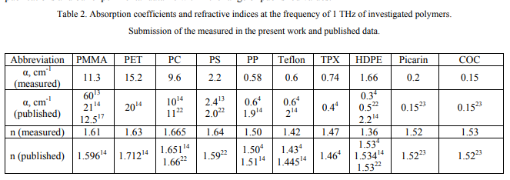

Figure .Absorption coefficients and refractive indices at the frequency of 1 THz of investigated polymers. Data from paper 2

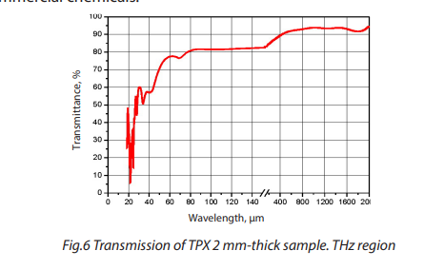

Figure . Transmission of TPX 2 mm-thick sample. THz region, normal incident. Data from [THz Materials](https://www.highlightoptics.com/upload/20180906/THz%E6%9D%90%E6%96%99-Datasheet.pdf)



Figure . Transmission of TPX under 119 um with 45^o incident angle , I calculated based on the parameters given in paper2.



Figure .Reflection of TPX under 119 um with 45^o incident angle, I calculated based on the parameters given in paper2.

**5. The beam profile of FIR laser and its parameters**

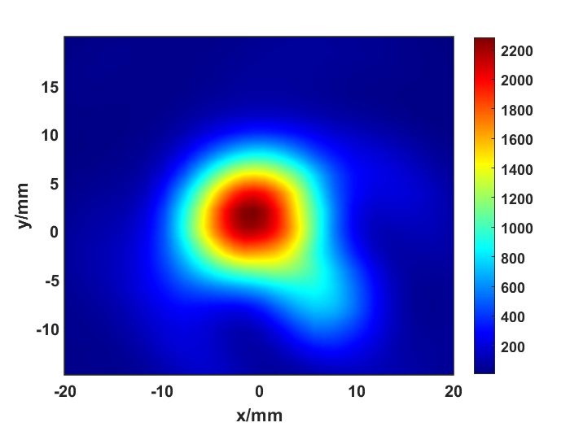

Figure .The beam profile of the FIR laser at z = 73 cm.

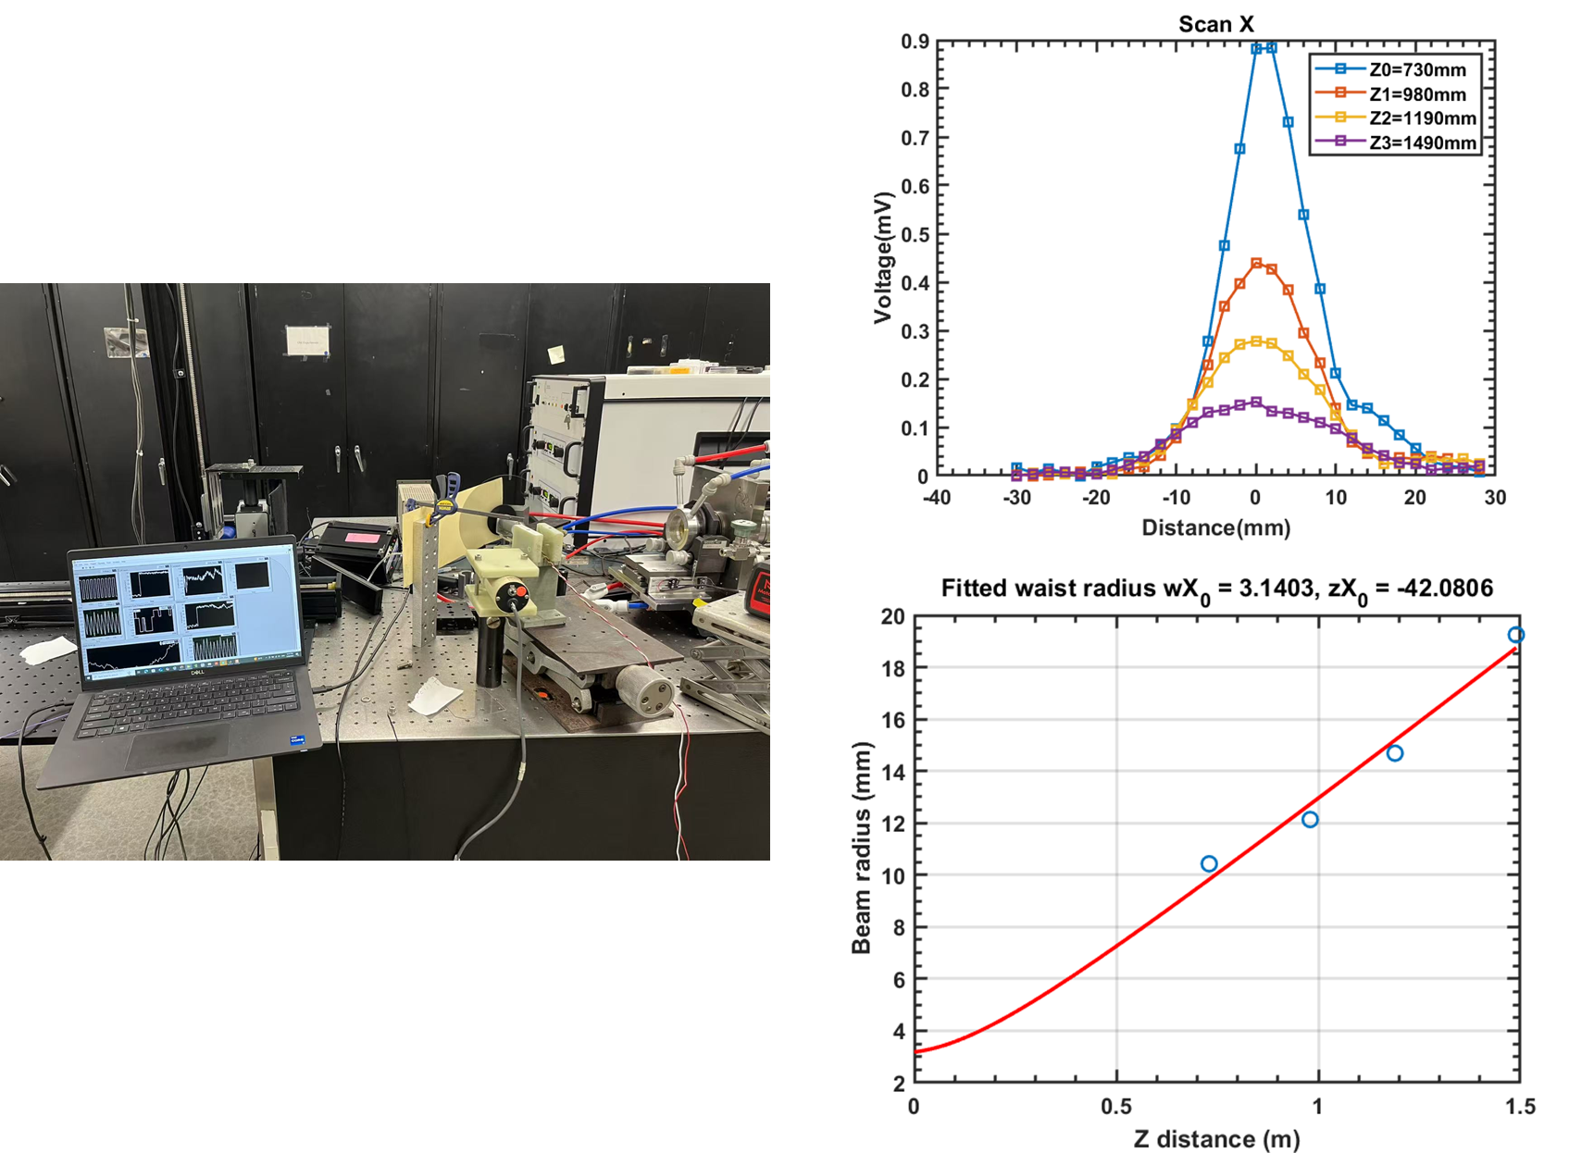

Figure .Measurement setup(left). Beam profile at different z position, where z is the distance from the detector to the output window.

Since the beam size varies with distance, if the combined wire grid is placed 0.5 m in front of the laser, the wire grid should have a minimum size of at least 8 × 2 × √2 ≈ 22.6 mm. The same applies to the beam splitter.

1. Development of Laser Based Plasma Diagnostics for Fusion Research on NSTX-U, ROBERT ADAM BARCHFELD.
2. Studying of dielectric properties of polymers in the terahertz frequency range